***PAAREES PERFUMES***

***DAVIDOFF***

***FOR WOMEN***

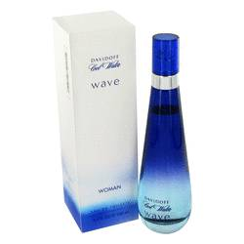

# *Cool Water Wave*

***Description:***

Cool Water Wave by Davidoff Perfume. Conceived by the design house of Davidoff in 2007, Cool Water Wave is a light and airy women's fragrance. Fruity and tropical, this scent features top notes of passion fruit, guava, mango and watermelon. Its easy, casual feel makes it an ideal fragrance for a summer day on the beach or shopping with friends. Floral notes of peony and freesia add a delicate feminine touch while a hint of pink pepper spices things up a notch.